**Q1:** Let us discuss project success and failure. What is your judgment on these projects? What demarcates success from negligence, or vice versa (this is an open discussion about KPI, metrics, etc.)

Please pick up one of the below projects, conduct review, and conclude.

Project 1: Federation Square (Not Successful because It is delayed)

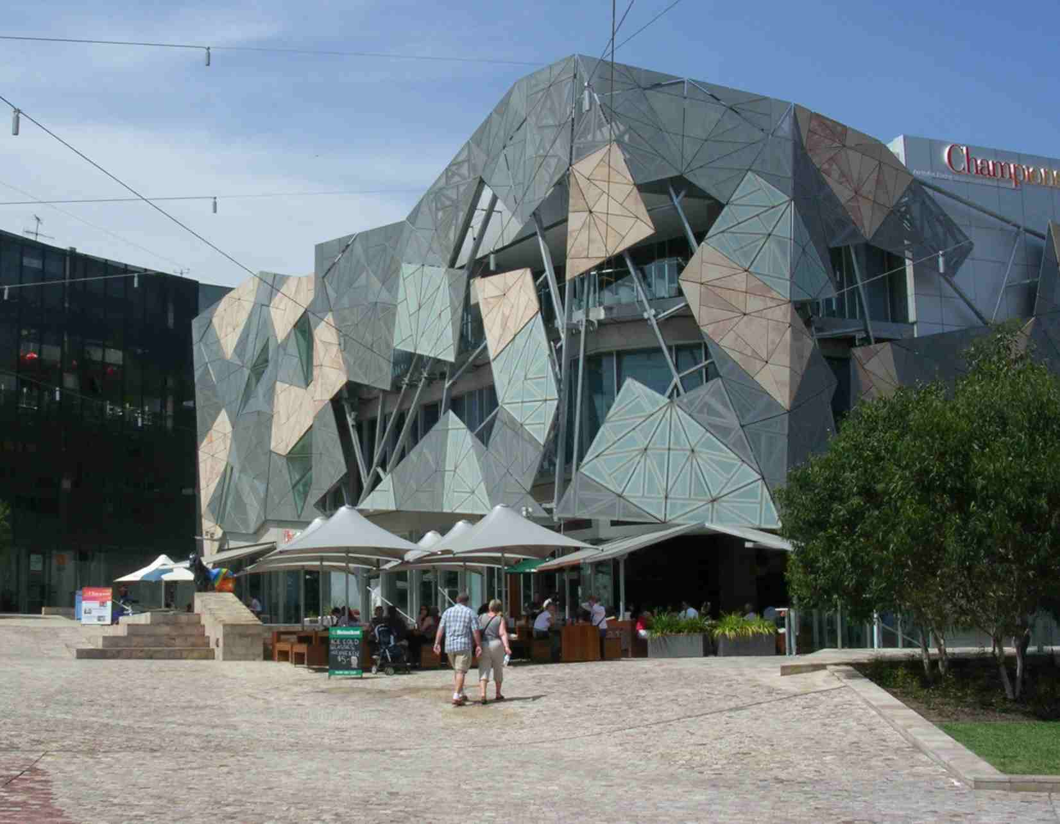

Project 2: Project:  Hoover Dam

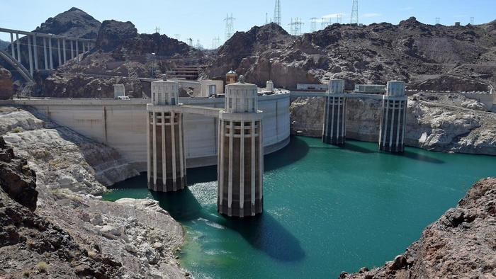

Project 3: Swanston Academic Building (RMIT building 80)

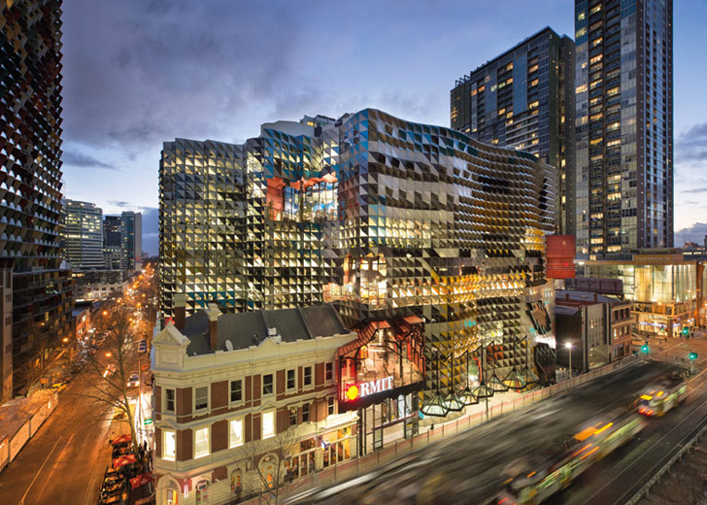

Project 4: Eastern Treatment Plant Upgrade

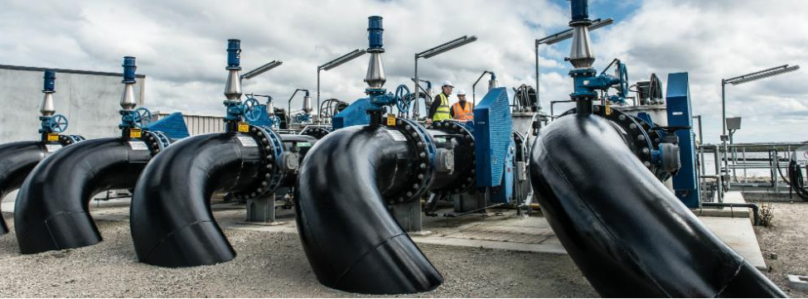

**Q2:** The Victorian Government had decided to build a desalination plant. Before the plant could be built, a full-scale evaluation of the project must be undertaken. Construct a life cycle diagram for the Planning and Evaluation Phase of the project. Clearly showing the tasks you can think of it.

**Q3:** Draw a simple work breakdown structure for the manufacture of a bicycle and explain the benefits of using a work breakdown structure.

**Q4:** A bit of open-end discussions around the difference between project sponsors and project owners, high-level project plans in the initiation stage, etc.